^{c:} 3⁰³⁰a
a)
^{a)}a)
^{='a)Q.} 0
0
0
^{CD}m
W
;D
²0
=
g
)>
<
(')
:>g
0^{[.n}
D
-1
^{c)}2
2
D
0
D_{c:}
0=
=
⁰2^{Qa0}00
2:
₀⁰0
0^{CD} 0
^{'D0}0
<
0
0_{c:}
^{B03}0
^{cnc:} a)_{cn}
^{=DC}8
CD
a)
0_{CD}
CD
CD
CD
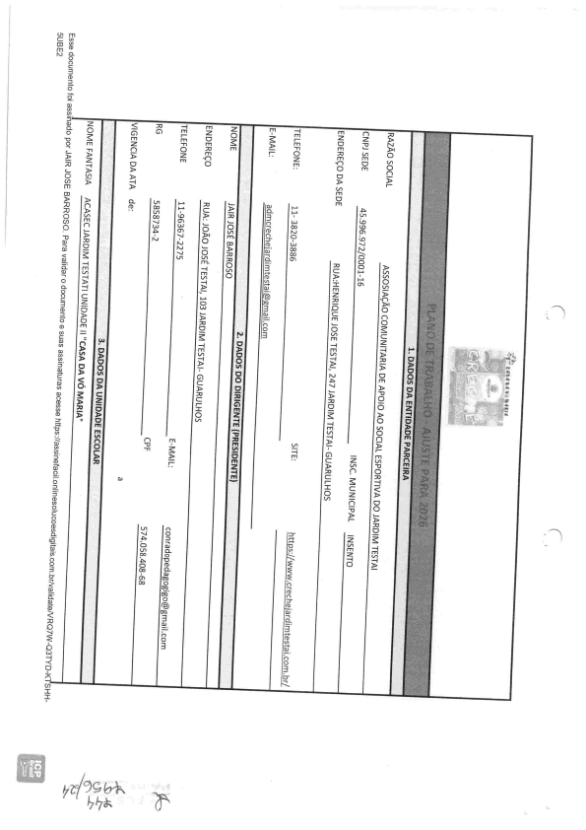
00
3
'-q
0^{)'z}0
.Êb
'-q
>n
!3'
lxo
0
=
{.n
Q.
-q
-q
g
g
-q
a)
^{c:} 2
:> 0
^{)>D0}g
-]
^{Q}0
g
.{
^{Q}0
^{G)} C
$ ãl;lç
)>
H
C
é
g
⁼0
2
-q
^{'u} a
''D
=
⁰⁰0
00
00
^{D}C
^{),}=
^{D}D_{C}
0
-1
g
.IS
⁰=_{-q}
g
-1
0
:>
()
('1
^{(D}g_{C}
g_{D}
:>0
>.
^{''D0}0
0
0
:>
⁰9
?
0
>0
'D
#
#'
^{:0}a
0
:
⁼0^{cn} 0
C
8
^{cn}Q.
CQ
a)
c.n ^{.êb} 0
0_{D}0
⁰Z-q
la i-i
⁶⁾c: ⁼0
g_{C}
)>
2
-1
0_{D}
⁻¹<
⁰0
D_{D}
⁼-q
R^{I'n}a>
⁰0 g
()
g
ã©
e^{n}0^{''q}g
00
'D
0_{aQ}
⁰®3
⁰3
E
Í€ F3'
g
-q
0
-<
X
a'
:1
:t
Çbà;>
^{c:} 3⁰3
⁰a a)_{cn}
3_{a)}
0
0
'0
Õ<
Q
^{3Q}3
' ' n
₃3 Q. C
=. 0
^{''' Ón} Q. 0
^{)>0}3
m
Z ^{''D}0
²⁰a
:>D0
Q
^{'u}U
3_{D}
-..h À. '-
. 3
^{0 =.} C) D
3^{D30}3
a o
⁰2
C
0
^{CD}mW
>
:D
^{:D}0^{CD} 0
^{H}D
C_{3Q.} ^{©Q.} D
Q_{Q.}
@
D
^{h}3_{Q.}
D₎
S
Q. ®®
0R^{nn}3
^{= o 5 2}3 ^{Q õ} R' u ⁰ 0^{.b 8rD}m
^{Q.}0
0 .Q
0
0 u
⁼0
0
^{Q.} _{Q}2> g^{3(D} 3^{.ê-} 0₀₀^{c:} g
'u
<D
0
0^{c:} 3
Q
n^{Q}D
3^{D}3Q
0
3^{a)} 3₃
Q.
B
R
€_{D}D
3
D .Q
3 '8
h-' 3
g
:>Q
ro r") -q
rD
C
0
W
2: ()
Z
⁰⁰0
0
>.
.Fs
^{g}0
⁰0_{)'i}
_{C}'1
(D
^{:0}0
^{'0}rD0
D
g' a' ₃
_{g}8
³3 :
c:
n
''q
0^{Q}00
()
D
C_{a)} :a)
8
=' Õ Q. m' o àj
0
' 3 .g
Ê- ' 3
g
n 3 o
a:' a0 0-
⁰33
H⁰2
^{C}B
CD
CD
0
2
^{C}0 ()
0
=
g
G) c:
c:
0
C
⁻⁻¹''n
g
t'D0
.b
^{Q}g
-1
8
-q
^{D}C^{-q}D
E .1 8' g' ã :
0^{2:} g
³⁰a⁰3
0
=
0
⁰3
_{aJ-} c)
=
g
0_{C}
c)
⁼0^{cn} 0_{C}8
8
^{Ó}₃0 C
8
D
^{D}0
30
c:
: í g:l
<
0
2
-q
^{.Êb} .Êb
']
F
⁰3
$Q)
^{a)}F
?0
0_{B}
^{D}D₀
0
g_{C3}
tD
^{'0}D
D
^{c:}0g't $ g
-l (D .: E'. a}
<
Ç' ã e' .8 na '- c:
0³0
₀₀12. 3
®
3
^{''qg}0 -q
3
0
³0⁼a
03
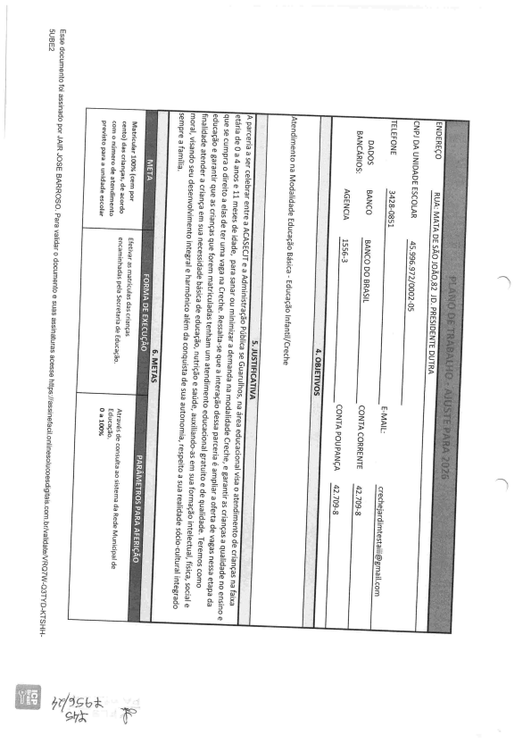
Q)
><
^{-<}c)
e g₀
0
-]
fD
CD
1:
:r
^{bk}F
(n m c ü
^{C3030}a
^{D}a₌
0
0
>
0
^{mm>}n^{D}0
^{CD}0
'D^{D8}<
Q)
0
0
^{C}3®3⁰0
^{cn}C
cn
=^{n) C}8
CD
^{a) ()}0
CD
(D
CD
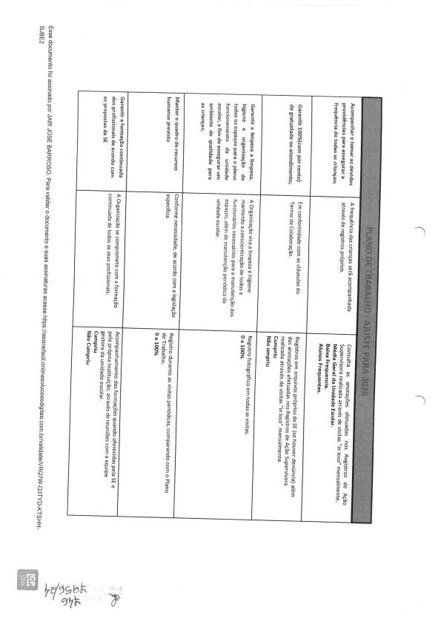
â'
= '=
$' R
m
0^{Q.} 0
₀n
³⁰a0³⁼⁰0^{c:} 8_{ca}
QD
8_{R}
^{Q.} 0
^{-qD}0' _{D}
0
<
D_{0aQ}
0^{Q.} c' ^{D}3
0
D
0
Õ_{aQ}^{n00}3
'0
Z
0
G
3
e
⁰0_{B}
^{=.} <_{D} a)
^{n}0
^{E}0
8- g
g.{ D Q.
^{'0}m 0,
t3
⁰3
^{'0}a
3^{Q.} 0
⁰3₀
'D
0_{Q.} <
' s. ã D
t/') ...x
g 9
€g
^{n} 3 lo _{rD}
³0
3
^{Q}U
0
-q
^{1:}:t
'9ç, k,k
9$»
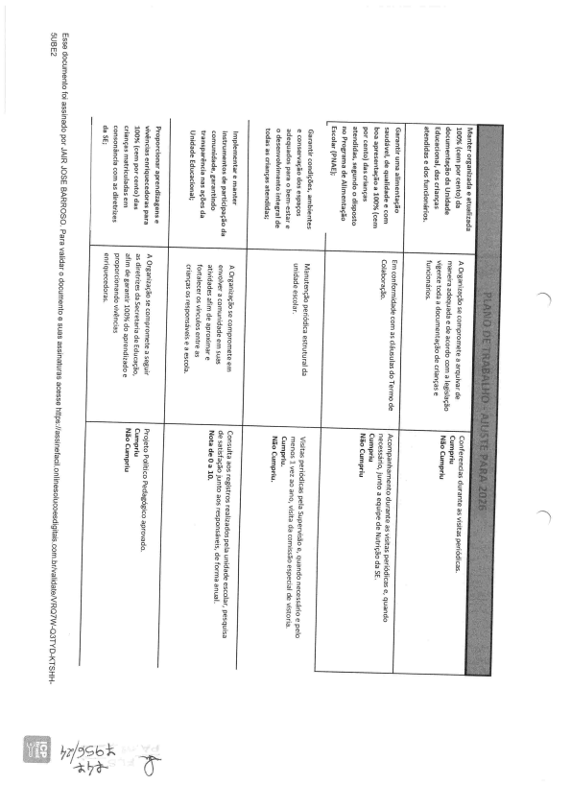
^{c.Ji m} c ü
0^{C3030}a
D
=_{D}
0
g
0
0
^{CD}m
W
^{n}0^{CD} 0
'D
⁸<_{a)}
í ã'Ê. {
^{a)} 0
0
^{C}3^{®3}0₀
C_{a)cn}
co
3_{D}
C
B
i
^{a) ()}0_{CD}
ã ' { * _{m Õ}
CD
t3 'u
a)
2
0
^{cn30}a
⁰³⁼⁰0_{c:} ⁸0_{Q.}
^{e}3
'D
^{'q}e
_{e} 0 ^{'D}0
0
'Q
^{(D}Q.
8'
0
'1
'D
D
g
⁰3
$_{D}
^{(D}a]]0^{''q}E ^{-1-<}c) -d
⁼l
0
^{Q.} 0
-'tb-b7 }ZÓg t:, 'k
c.;i m _{CI co}
^{()C30}3₀
0
^{=Q.} 0
0
0^{-q0}g
WD
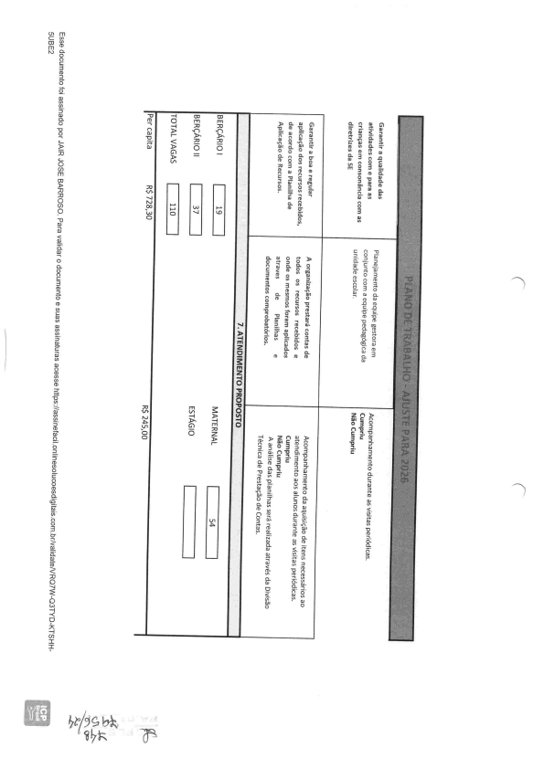
D
D
g. ^{D}0^{'u}0_{W}^{Q}Q. ^{B}n
^{Q.} n©
^{Õ}D
^{H}3
Q. o0
Õ
=
<Q. ©a. ₀
a_{D}8
<>
^{D}0
q^{Q.} 0
0_{â. Q}
^{N}n
^{'fl}DD
=
^{H}a' ₀^{D}0
^{Q.} _{D}U^{.Q}C
0 ^{CDm}mD ^{:D}0 ^{CD}0
^{''DD}B
<a)
000
â
^{g}e
^{UQ}n
0
3
U
^{'Da}3
^{='©Q.} 0
^{D}n_{C}
0
0
^{8B'}Q. _{Q}
n^{C}H
^{3a}0=
Q
=
3 U
8
³a
⁶0
³0
^{'D}D^{D}H
^{U}Q. ^{H}Q. _{m}g
D
Q.. u
^{C}0
'D
0^{Q.} 0
^{Q3a. 0}0
8' )'' i' .g
Q. ^{D}D
=
^{C3}0
³a3⁰³0
_{U} '')
^{C}3⁰³⁰0
3
3₀
Q =.
8
⁰3
Q^{n0}3
a. ₀^{Ó}_{e}^{Ü}0 3
m
c: _{a)} CD
n)
^{=DC}8
'-J
â^{Qg2}g
'u
^{Ó}u' _{H} 8'
^{'D}D=
©
Q
^{ã}3
D
'g
a^{Q.} 0
Õ
n
^{D}u'_{a. Q}
'u
^{Õ}B_{a}
Q
Ü
=
n. ©
.!:C ^{'0}© ^{'n}0_{Q.} 0
®
^{.Q}CQ
0
0
⁰3
00
Q.
D
⁽⁾0
^{CD}0
=
^{'uH}0
D
^{'D}0
=
CD
^{CD30}a
0:
⁼⁰0^{C}8_{0a)}
.D,
00
-q
D_{2:}
8
^{-d}rD
3
^{Q.} 0
'D
0
⁼Q. 3
3
0
⁰3 ^{'0D}3^{a30}3
'0
Z0
e
3
C
'u
e
3
C
>
⁰3 ^{'uD}3
³⁰3
0^{Q.} C
⁰a
^{'0D3} '1
0
0
D
⁼0_{D}
a0₃
$
^{Q) B}2⁰ê ()
^{0Q.} n⁰2_{D}
0 0
8
Q<
C Q.
0 D
Q. C<
^{'a}D
g
D
-q
-<
X
-q
CD=
=:
0^{' a}0
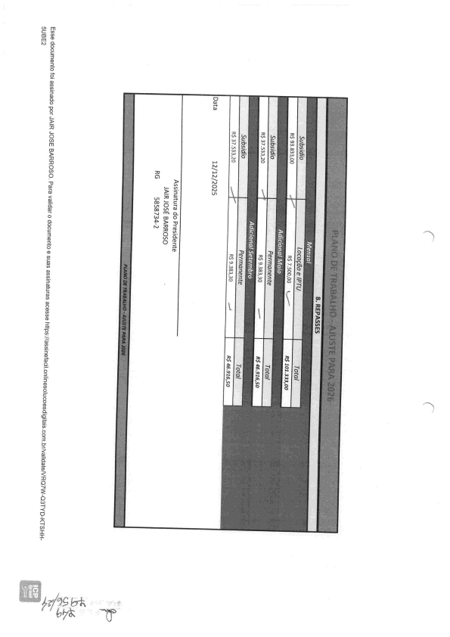
^{CJI m} C ao ^{()C3}0³⁰a
cn
=
^{a)Q.} 0
0
),
0
m
m
^{:DD}0
^{CD}0
^{'u}D
a_{<Q)}
D
0
0^{()c:} 3⁰³⁰0
^{C}0
CD
a)
^{a)}3
C
a)_{cn}
a)
0
^{CD}0
H:
cn
:k
^{cnD0}a
0₌
³0
^{cn}0_{C}
⁸0_{Q.}
0₃
ã_{a)}
^{a) 0an}0
^{g}0
^{-q}-<
-q
CD
^{:1}:r
:>
=
C0
rD
3
rD
')
1:.#n,ü "''"b
m m
⁸3
_{g}g
0
d'_{a)}
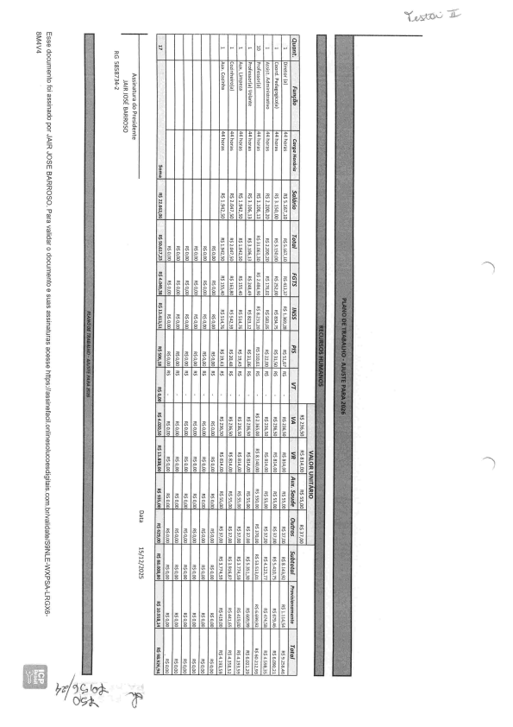
nl- Q..
3
> -D
0
0
m
>
0
^{(D}m
^{n}0
^{CD}0
'D
B
<0
0^{Q.} 0
^{C}3⁰³0
c:
a)
^{CD}D
3
^{c:} a
a)
0
k:_{a)}
³a
⁰³³⁰0_{c:}
g 19
oo l o.
0
(D
+.
^{cn}Q.
Z
Q)
g. ^{D}0
⁰3
D
$
Q.
Q)
(D
CD
Z
m
$
P
'D
CD
>r'
0
><
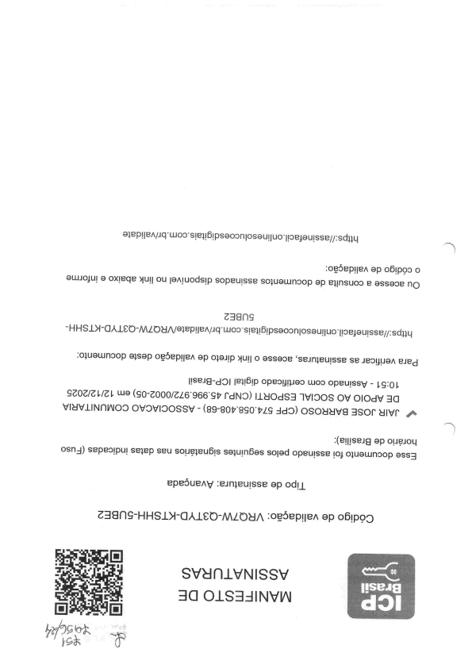
a+eplleA/iq uuooslei161 psooonlosaulluolloe+oulsse//:sd)}y ')
o95eplleA ap o61poo o
auliJO)ul a oxleqe )lula ou laAJuodslp soPeulsse so+uoul.in90p op e+lnsuoo e assaoe nO
HH Sly-a,AIC C)-MZ t)UA/aleplleA/iq Woosle+161psaoonlosaull uo llo elaulss e//:sd+iq
:o)uouin30p a)sap og5eplleA ap olaJjp )lull o ossaoe 'seinleulsse se Jeoj+jloA eled
llseJ8-d91 1e+161P OPeol INDO UJoo opeulssv - l.ç:ol.
çzoz/z l./ab uuo (se-zooo/zz6 966çt, rdNC)) ]]UOds] IVIC)OS ov O]odv ]a viuviiNnmoo ovovloossv - (g9-80t,'gço't,zç Jd9) osouuv8 3sor uiva ^{,1»}l (elIJsei8 ap oliçioq
osnJ) sepeolpul se+ep seu soliç;eu61s se;uln6os solod OPeulsse lo+ o+uouinoop essa epe5ueAy :ein+eulsse op odll
238nÇ-HHSl>1-a,\leC)-MZC)U/\ :og5ePlleA op o61poC)
SVUniVNissv
3a OiS3JiNvm
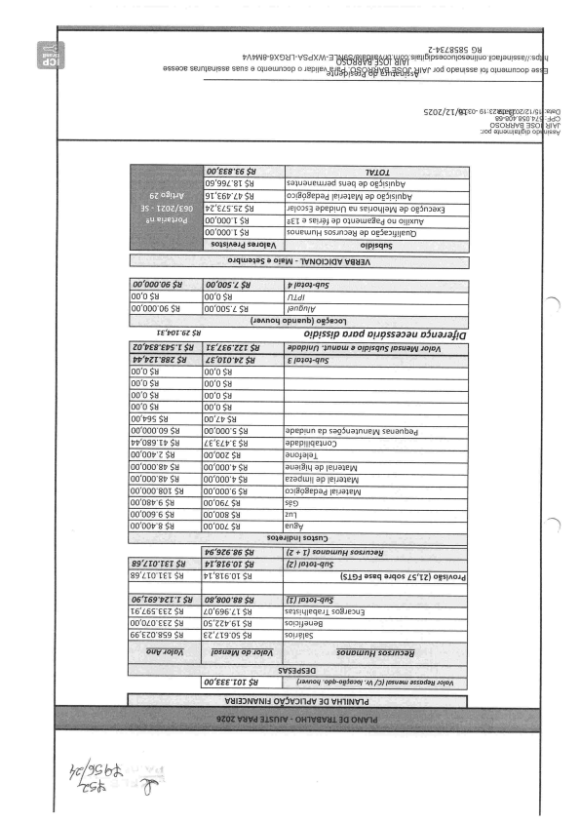
Z-tEZ8S8S 9U
P/\ t,m 8-9xE)}Jl-VSdXM-3 't5919(NÇqlgêtjjt g119r sle;161psaoonlosaulluo lloe+oulss e//:sd+ju
associe sein+eulsse seno a oluounoop o ieplleAaBtli$btÇl99yfV$1jãçjlj;êjlvr iod opeulsse loJ oluauunoop as
szoz/ZT/glco- 6 b:czwp Foz/z L/ç uj:nea
99-gO#'gÇO''PZ g :JdC)
0SOUUV8]S01UIVr
:Jod oiUOUJje1161P OPqUJSSV
q4qma+aS B a]eW - ']VN01]1aV V8Ü3A
aóbaaoõ SN oo'oos'z $& b'!nio}.qnS
oo'o $u oo'o $u
00'000'06 $U oo'oos'z $u lanõníy
t aAnaq apuenb} o95ma]
za'Pf8cpsrs8 [e'íE6'ZZt'$U apopluf} ')suou a olpJsqns lnsualN iofol\
W'PZ i' 88Z $H /f'oro'PZSu EI ai-qnS
oo'o $u oo'o $u
oo'o $u oo'o $u
00'0 $H oo'o $u
oo'o $u oo'o $u
^{00'99S $U} oo'zt,$u
00'000'09 $U oo:ooo's $u apeplun ep saQ5ualnueH seuanbad
PP'089'tt $U ZE'eZt'e $U apeplllqe+uo3
oo'oo+'z $u oo'ooz $u auolalal
00'000'8P $U oo'ooo't $u aua181t4 ap leliaielN
00'000'8P $H oo'ooo'# $u ezaduull ap lelia3eN
00'000'801 $U 00'000'6 $U o)l8ggepad lelialeW
00'08b'6 $U D0'06Z $U s99
00'009'6 $U 00'008 $U znl
00'00t'8 $U oo'ooz $u
salailpulso sn3
P69Z6'86 $U$$g©lg l (? ]' [J souownH sasuniaU
89710'rFr $8 pz:9i6'0r $u ÍZJI }ai-qnS
89'Zt0'tEt $U kt'8t6'0T $U IS.L93 aseq alqos ZS'lZ) ogslAOJd
a6'16s'pzr'r$H 0e'80Q'88:$U [} tniol-qnS
^{16'Z6S'eEZ $U} Í0'696'ZT $U se[s[t41eqei.L so8ie3u]
00'0Z0'eEZ $U 0S'ZZt'61 $U solalJaua8
$6'eZ0'8S9 $U EZ'ZT9'0S $U soliçleS
^{auV:bafo/t lnsuaIAl;oP:falDA} sounmnH sosin3ay
svs3dsãa
VUIa5iÜÚÚIj ÕÇ5Ç5iÜV 3Q VHI INVId
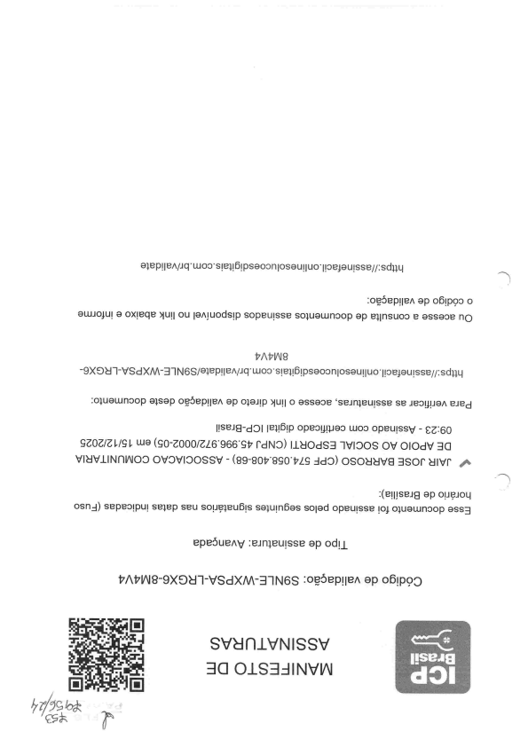
alepll eA/iq uuoosle+161psaoonlosaulluo llo e+a ulsse//:sdliq ''1
og5eplleA ap o61pgo o
auiio+ul a oxleqe )lula ou laAluodslp sopeulsse soluauinoop op e+lnsuoo e ossaoe nO
9X9U 'l-VSd X/\A-31N6S/o+ePlleA/iq uuooslei161psaoonlosauliuo llo eJaulsse//:sdl+LI o+uouunoop alsap oç5eplleA op o+oilp >lull o ossaoe 'sein+eulsse se leal;flioA lied
llseig-dc)l le1161p opeol IHao uuoo opeulssy - eZ:60
ÇZOZ/Z l./ç 1, wa (ç0-Z000/ZZ6966çt' í'dNC)) ].LUOdS3 ]V]C)OS OV O]OdV ]C] VÊuviiNnmoo ovov190ssv - (g9-got,'gço't,29 :Jd9) osouuv8 3sor ulvr ..+ '''x
:(ejjJSeJg ap oliÇioq
osnJ) sepeolpul seiep seu soliç+eu61s so+uln6os so]od opeu]sse ]o+ o+uownoop asse epe5ueAy :ein)eulsse ap odll
t''/\t'mg-9XE)U']-VSdXM-3]N6S :oÇ5ePlleA OP o61PÇ)C)
svunivNissv
3a OiS3JiNVm

